**ASSIGNMENT 3 – CRUD PROJECT – DUE 16th JUNE 2023**

**COMP. 5210 - WEB APPLICATION IMPLEMENTATION (2023 – S1)**

**Tutor: Bruce Tuhakaraina**

Samantha Maciel Prieto

ID: 30068382

**Table of Contents**

Project Brief……………………………………………………………………..…………………………………………………………..…….3

Database design..…………………………………….…………………………………………………………………………..…………… 3

Relevant Links for this assignment…………………………….…………………………………………………………………….. 12

CPanel login details…………………………………………………………………………………………………………………………...12

**Project Brief – SCP Foundation files – CRUD Project – Create, Read, Update and Delete**

I have created my App on CPanel, using php files.

I decided for a simple design, where information was displayed clearly and concisely.

I tried to use Bootstrap, but I realised when I had it in place, my css file wouldn’t be picked up, for some reason. So, I removed Bootstrap.

I have used Google Fonts to get the font I liked the most: Raleway family. I am happy the way my work has turned out. The only functionality it’s not working is the Update button. The form loads correctly, and updated data can be filled fine, but when I click on “update subject”, I get the error 500. I have checked my codes quite a few times and can’t see why this is happening.

On my Index page, my image has disappeared, despite I haven’t touched anything on it since I started building this App. It was working fine before, and just yesterday it disappeared.

I have checked pages for responsiveness, and they also work as expected.

**Database Design**

Here I will leave a few screenshots of what has been done in Cpanel and how my App looks like, with all links and functionalities.

**CPANEL Main page**

It includes files: connection.php, form.php, index.php, styles.php, and update.php, along with the Images folder.

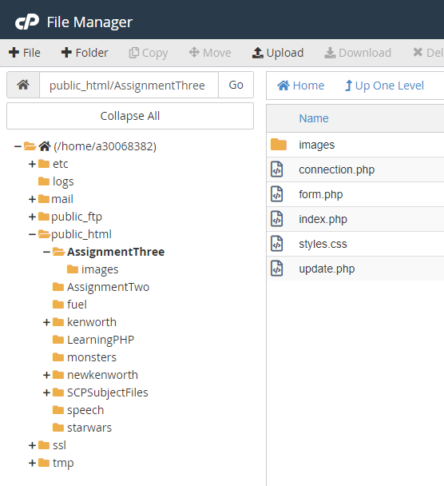

**Images folder**

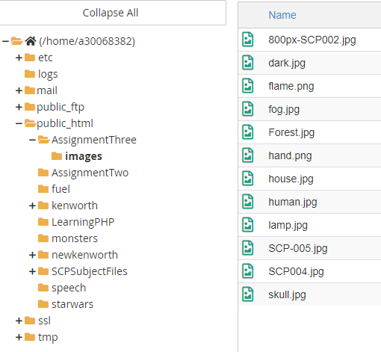

**PhpMyAdmin Menu**

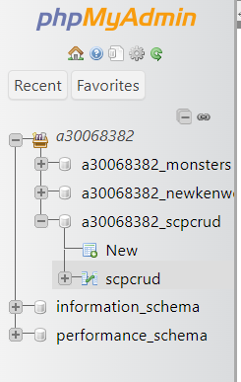

**PhpMyAdmin Structure:**

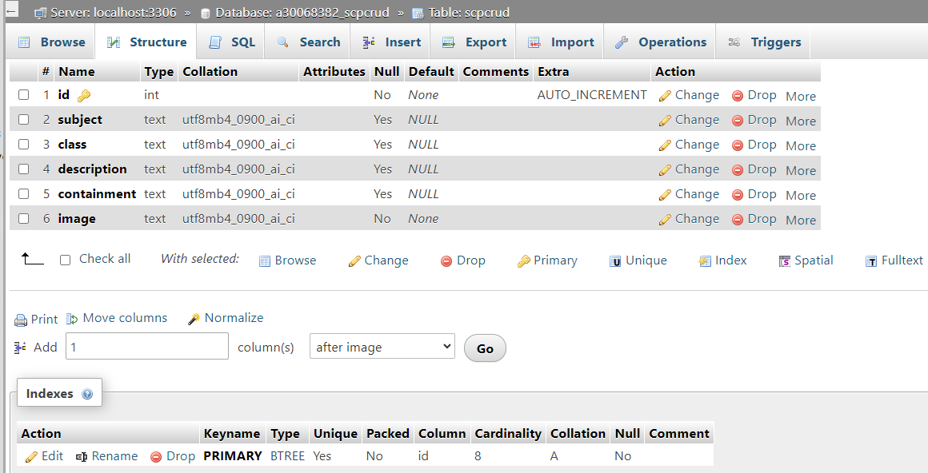

**PhpMyAdmin Browse:**

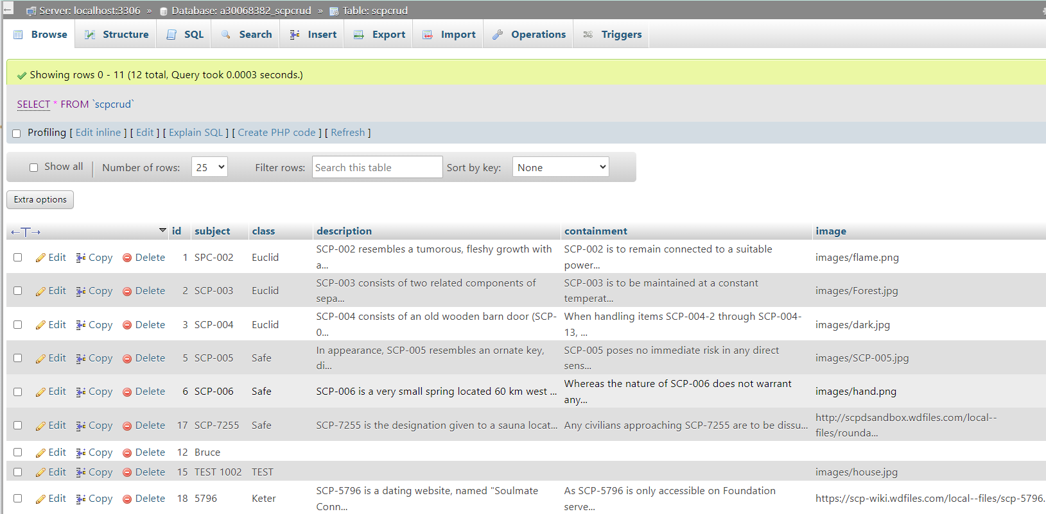

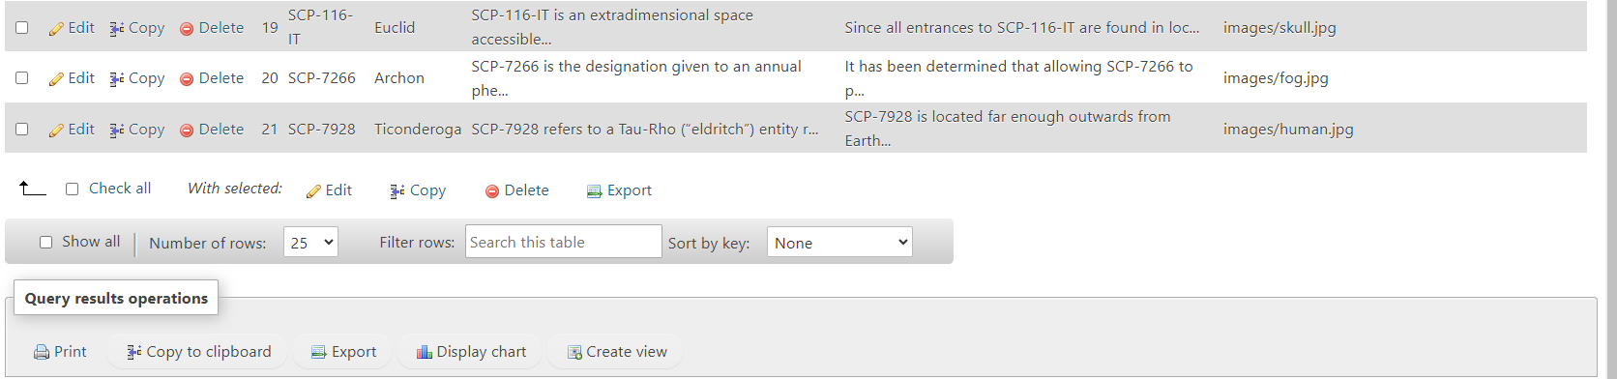

**Files that contain the App:**



**App screenshots**

Here I have screenshots of all pages on the APP. Please note a few of them contain an extra-large size image and even reducing the page down to 25%, we still couldn’t see the “Update Record” and “Delete Record” buttons. But they are in place, in all pages.

**App – Main page (image no longer loading):**

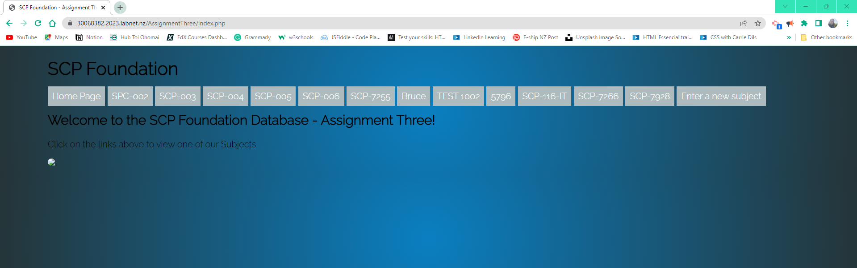

**SCP-002 Page:**

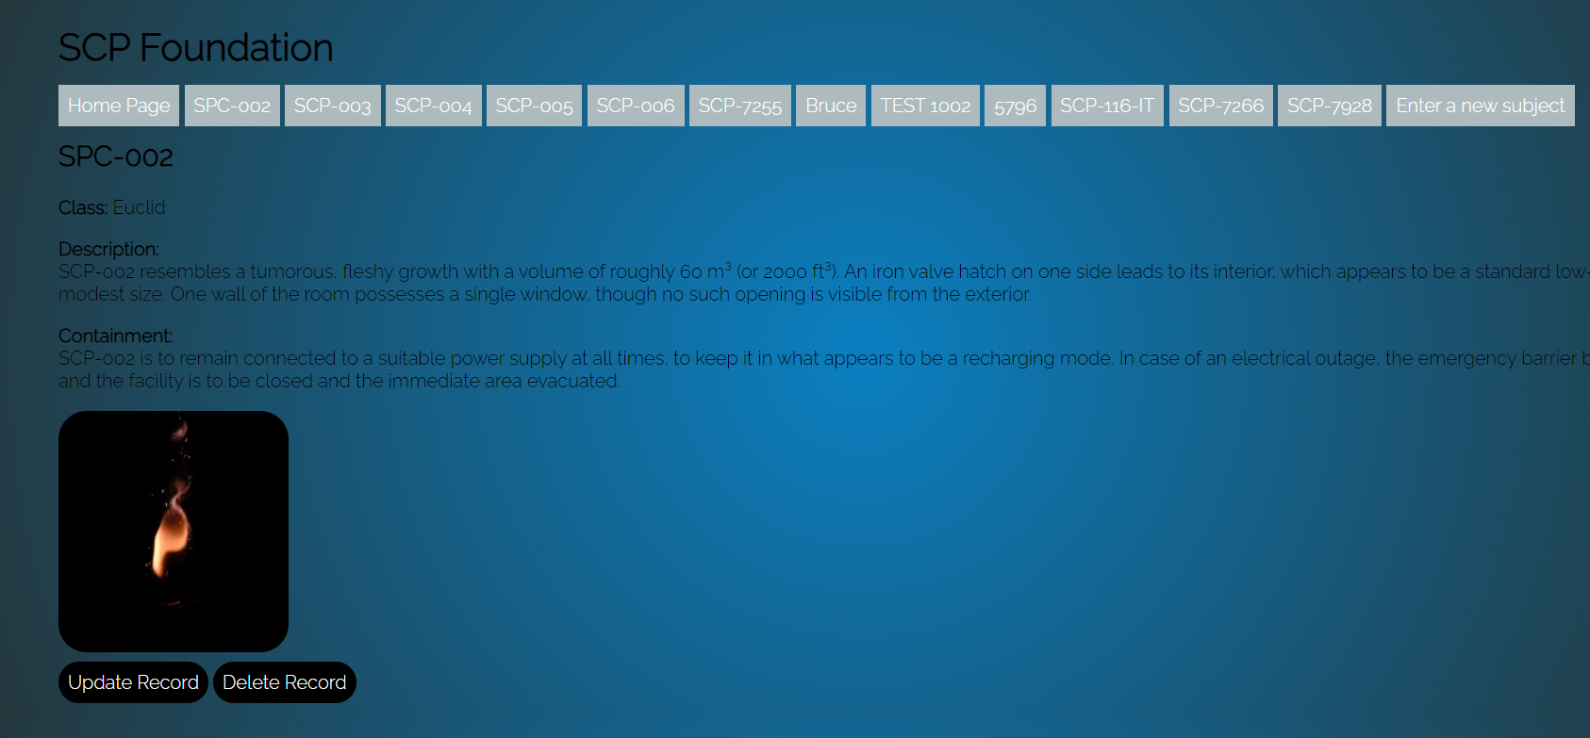

**SCP-003 Page:**

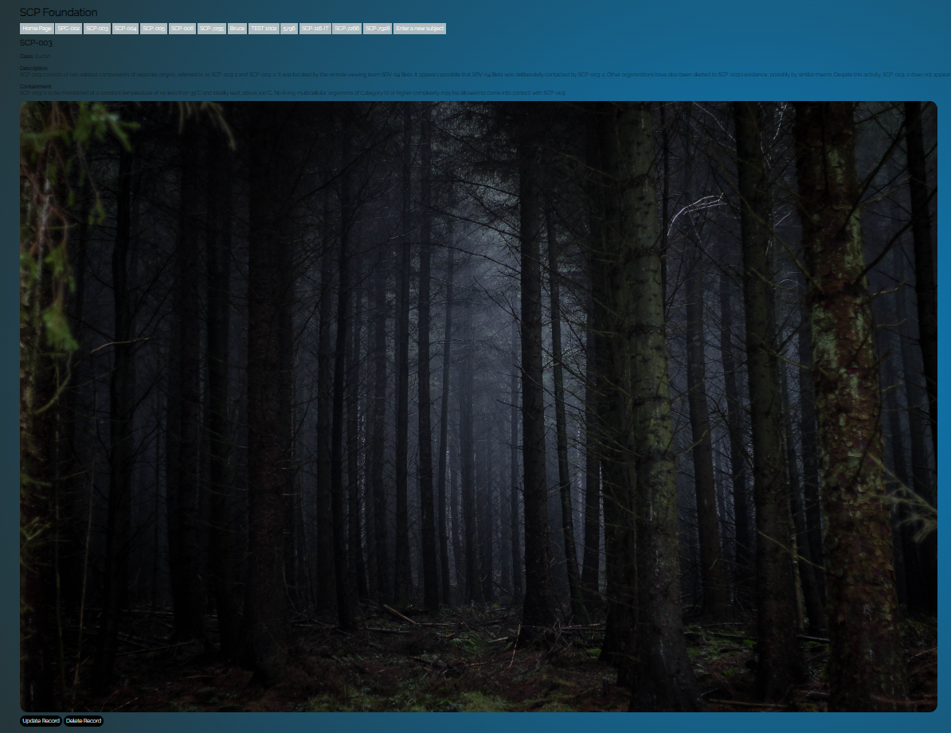

**SCP-004 Page:**

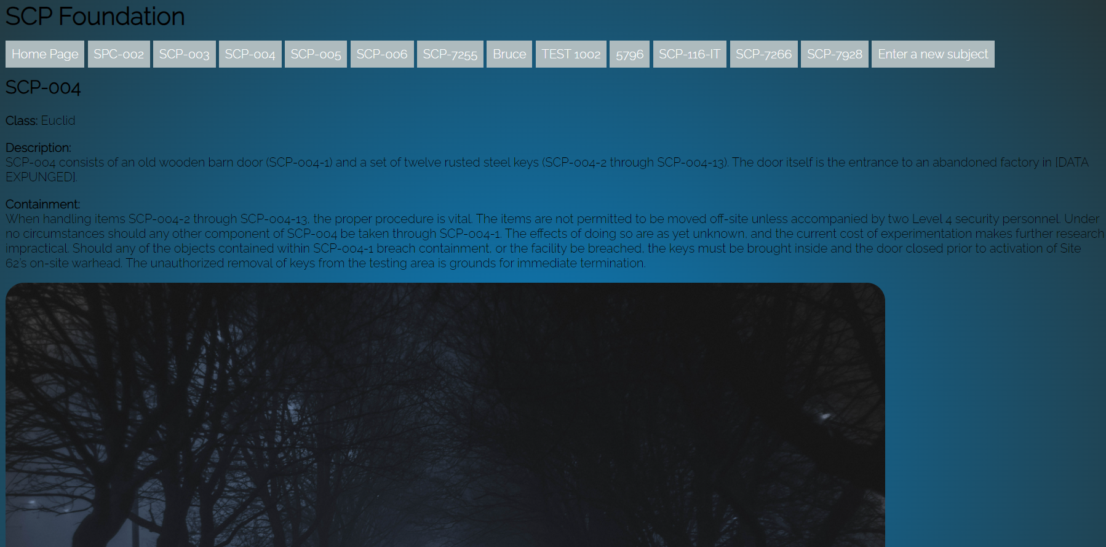

**SCP-005 Page:**

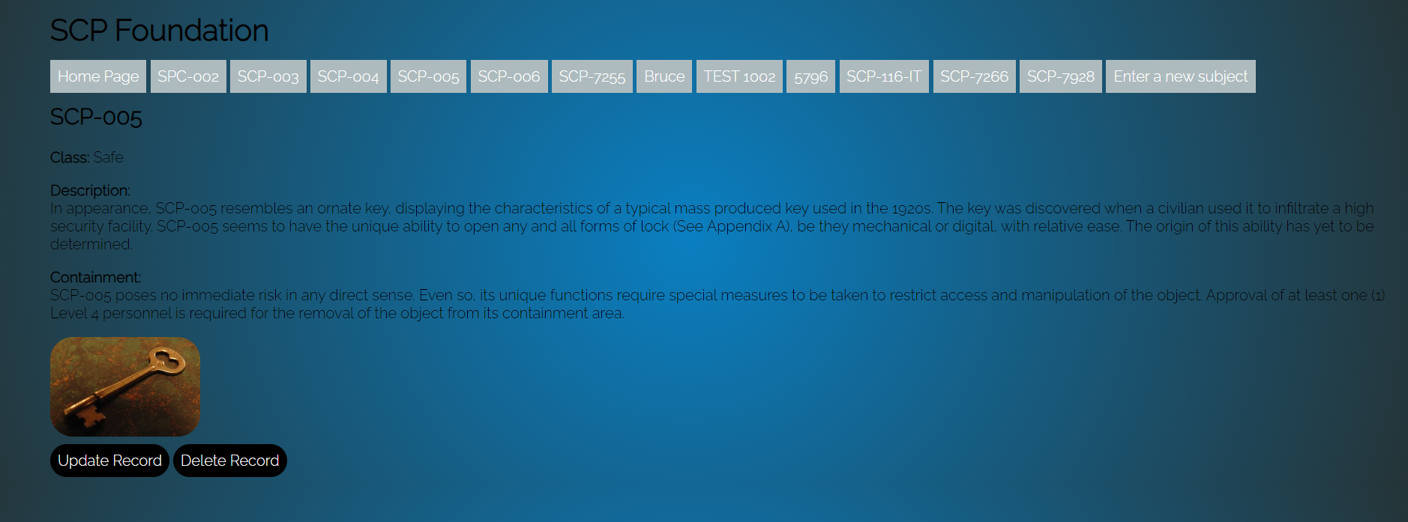

**SCP-006 Page:**

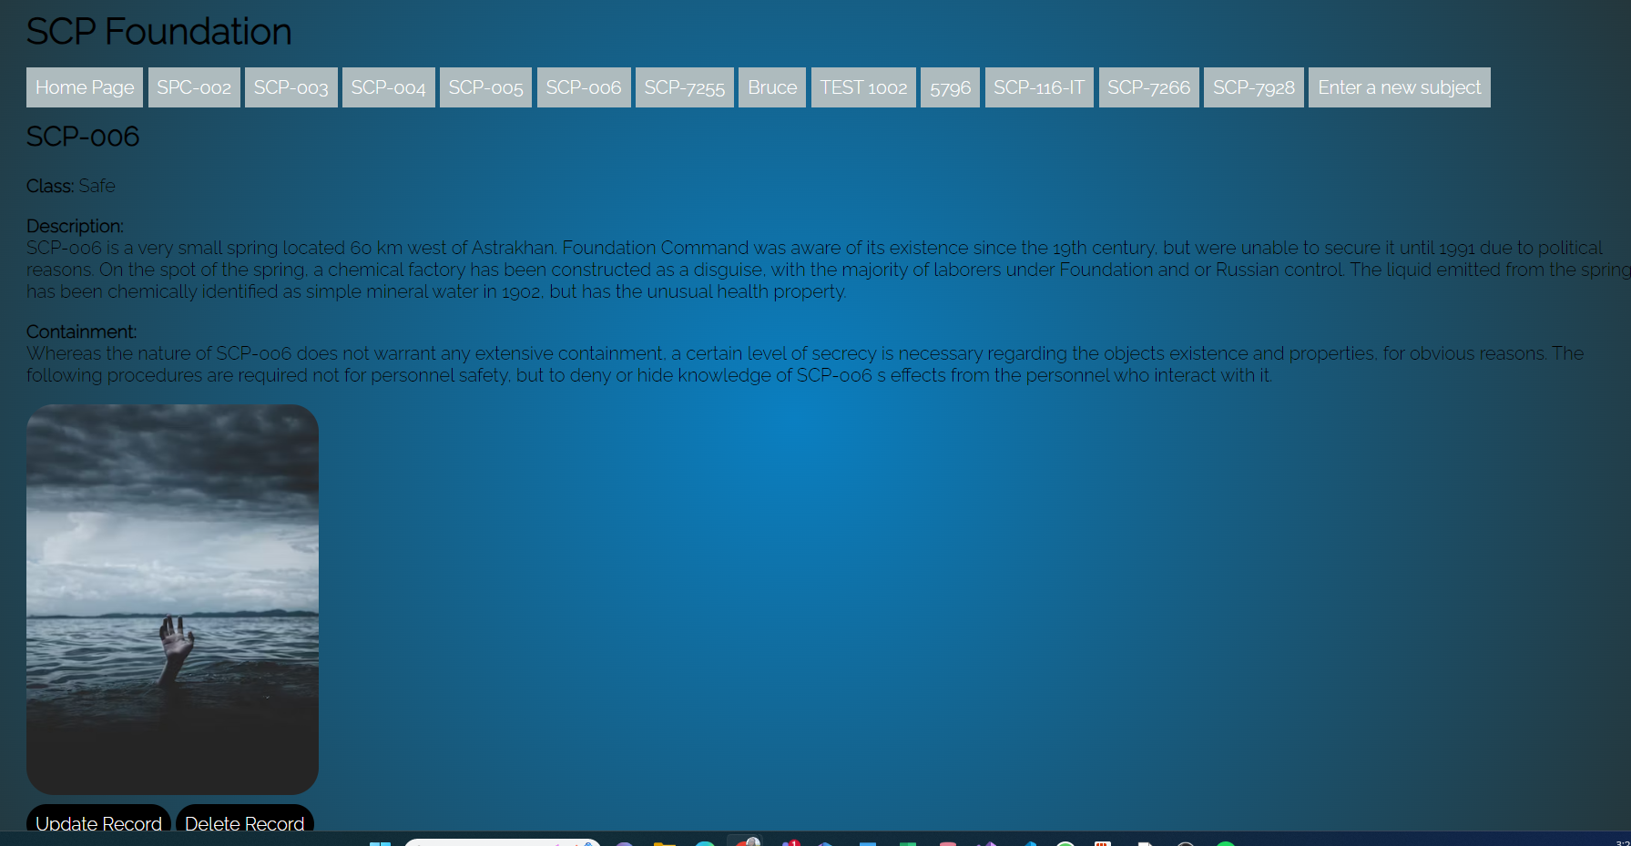

**SCP-7255 Page:**

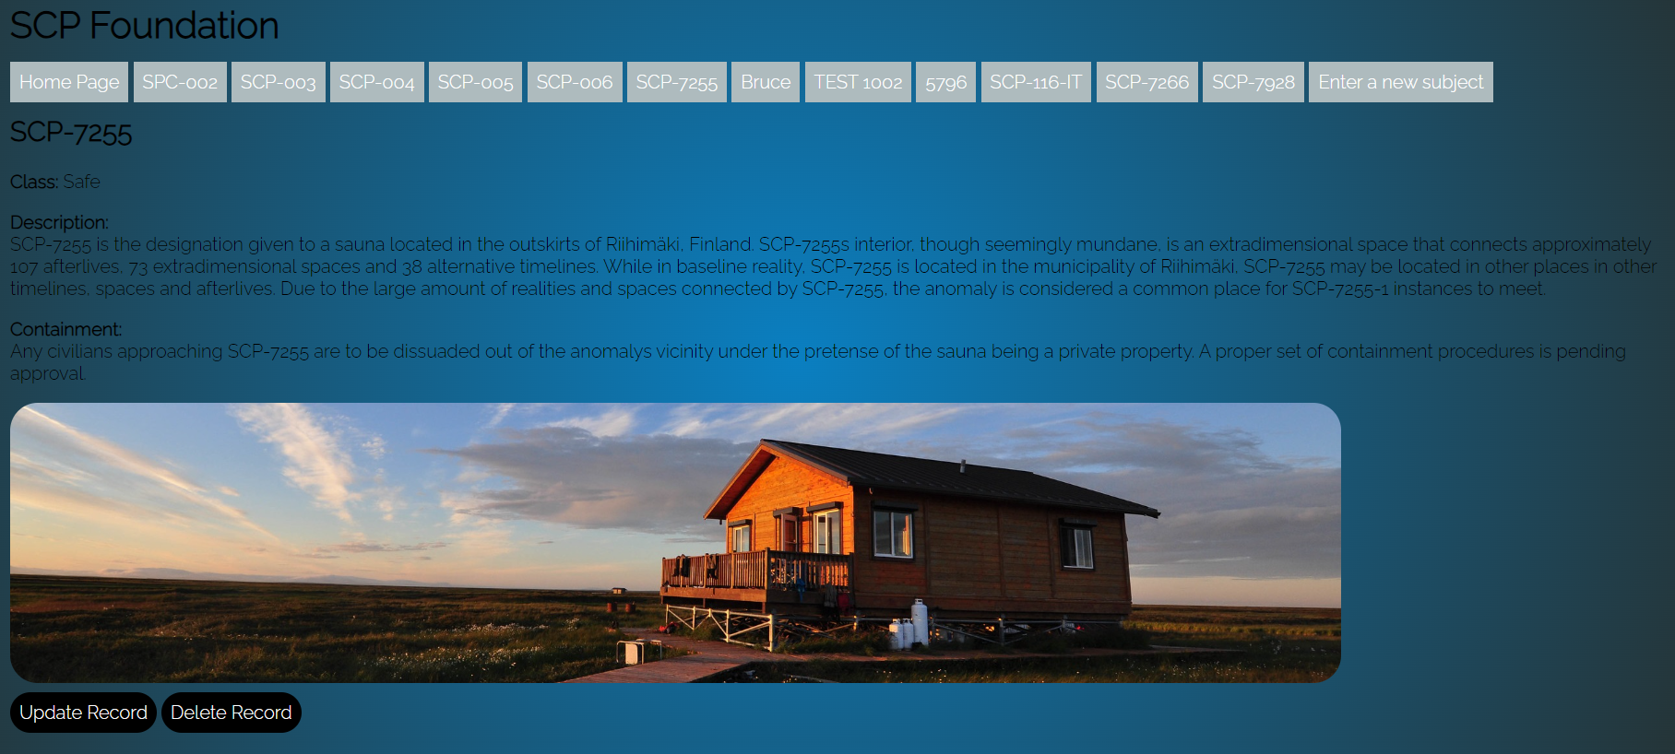

**5796 Page:**

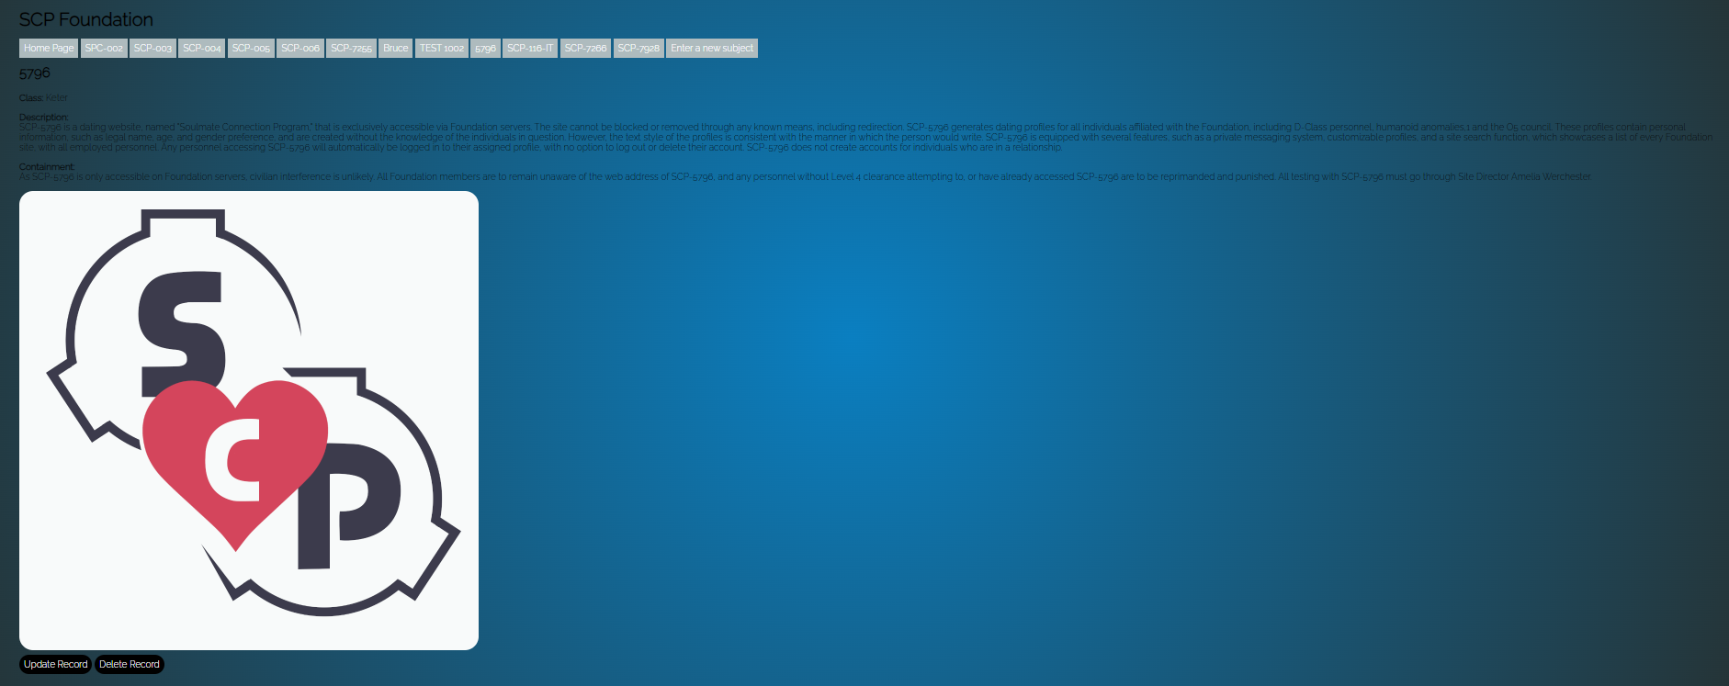

**SCP-116-IT Page:**

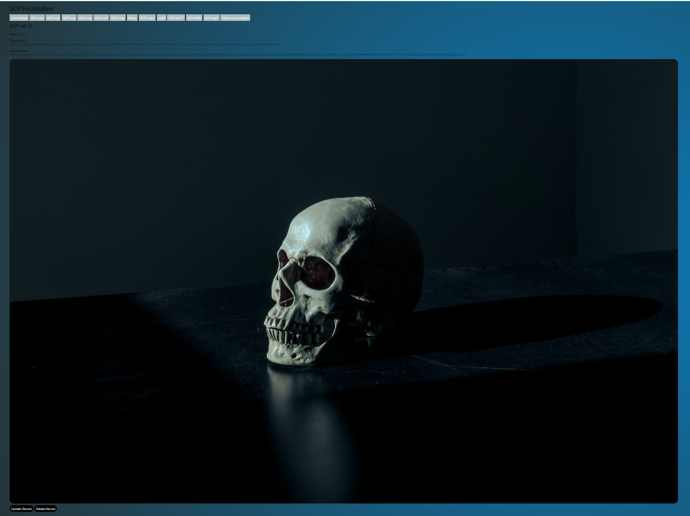

**SCP-7266 Page:**

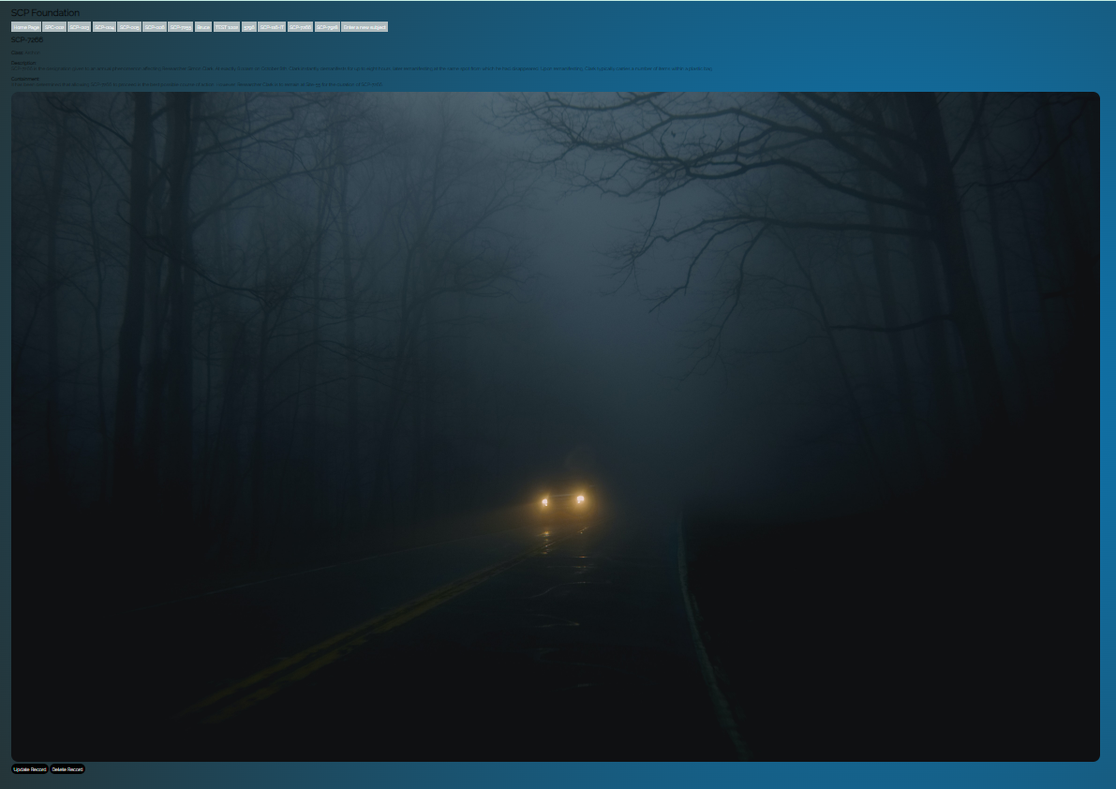

**SCP-7928 Page:**

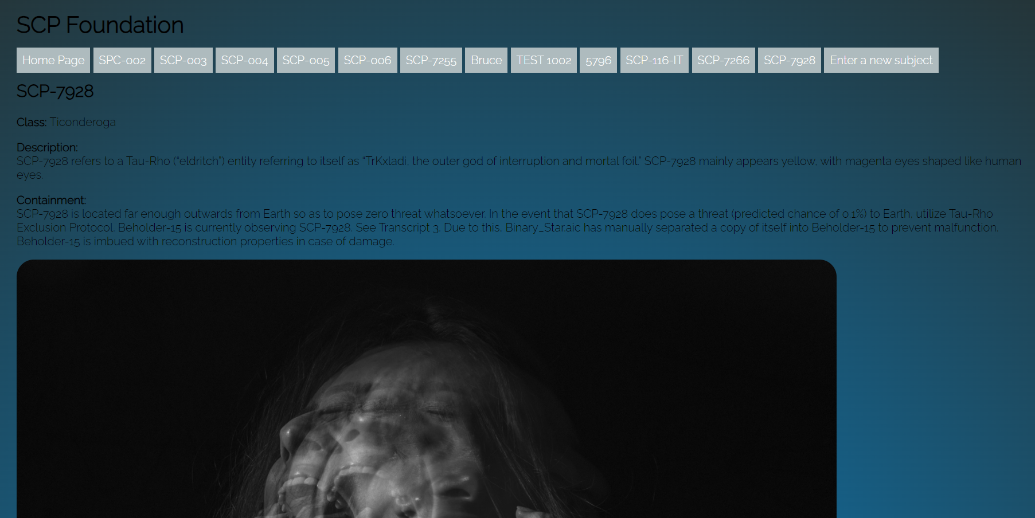

**Relevant Links for this assignment**

GitHub Repository Link (not required, but provided as I was able to do it):

<https://github.com/SamMacielDev/AssignmentTwo.git>

CPanel URL to the application:

<https://30068382.2023.labnet.nz/AssignmentThree/>

CPanel URL to my Form:

<https://30068382.2023.labnet.nz/AssignmentThree/form.php>

**CPanel Login details**

User: a30068382

Password: Toiohomai1234

